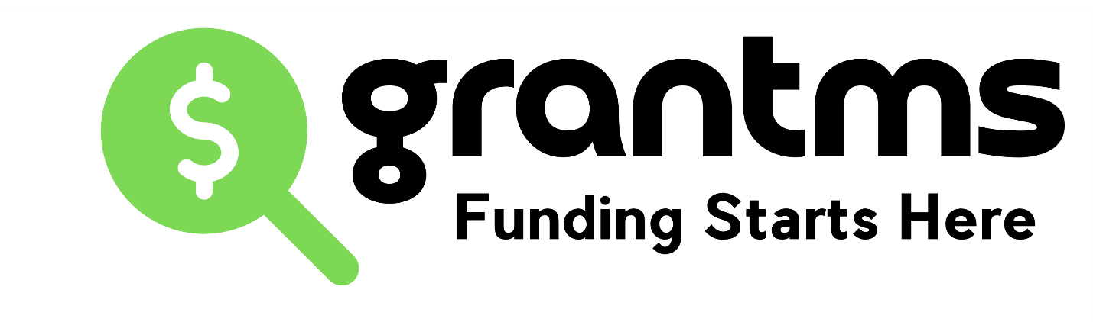Export Grant Guide
Core to writing export grants is being prepared to share your how, why, and your economic impact of expanding your business internationally. This funding has become extremely competitive in the last few years. It opens Jan/ Feb annually and often the funding is allocated by June. Important if planning to access, you add this to Q1/2 on your funding roadmap.
The government is looking to invest in companies who have a well-defined plan to grow strategically, companies who may already have spent money to build a footprint internationally, have potential business or have clients globally, and can share the metrics on how they will report successes. It also helps if you have been in touch with a trade commissioner (free resource you can access) to learn more about your market globally. Its valuable also to include the names of the trade reps (provincially/ federally) whom you have spoken to when completing your applications.
Programs are designed to either target helping you grow by innovating with another business in another country https://www.tradecommissioner.gc.ca/funding-inancement/canexport/innovation/index.aspx?lang=eng) or by growing your business globally (https://www.tradecommissioner.gc.ca/funding-financement/canexport/sme-pme/index.aspx?lang=eng)
This preparation is designed for the most common exporting funding “CanExport”. Most of the questions here will help you create content you can use for other export programs that may surface from time to time.
NOTE: Export funding doesn’t apply to franchise businesses or business consultants.

To Get Started
You want to have a plan on how to intent to grow in the country or countries you are targeting for your export project. If you need help creating a plan, many economic regions run a program called TAP: Trade Accelerator Program https://www.edc.ca/en/campaign/trade-accelerator-program.html) that can guide you through the recipe for successful global expansion. There are also private companies who help you build out a strategy and have resources globally to help you reach markets directly. They charge a fee for service and some of their costs may be covered in the export grant application. Request a referral if interested.

Start Date
Your project start date must be 60 days out from the date you apply. This is because the government is receiving many applications, they need up to 60 days to approve or decline your application. For example, if you apply for export activities (expenses) that start June 1, you need to ensure you application is submitted at the latest by March 1.

Share Plan for Growth
Funding isn’t just about you submitting an application to get a conference paid for as an example. In the content of your grant application the government wants to know you are taking different steps to grow your business aboard so it gets results. It is about communicating your rationale and strategy for expanding into another country.
Applications will get rejected if you don’t fully fill in details of the questions. If a section of the application gives you a 500 word count to explain your response, use the 500 word count. Keep in mind they will not contact you to evaluate your project. They will evaluate your project based only on the content you provide. Provide as much evidence of your projects readiness, your interest and expertise in expanding, and your ability to get a result.
Choose 1-2 Target Markets
The program shares you can select up to 5 target markets to expand globally but it is not advisable. The government knows its not easy to open doors in another country. If you are too divided (time/ money/ human resources) you will not have great traction or results. We recommend targeting one or two target markets and focusing on gaining traction in one place for a project. The more countries your project focuses on the more data and resources you have to provide about each market and the projected outcomes in each. Keep it simple and focus on 1 or 2 markets understanding the maximum federal funding you can access annually is up to $50,000 (matched at 50%. Meaning a maximum project is $99,999).

Export Development Plan
In 2025, an Export Development Plan became a required document to attach to your application. Most companies don’t have this in place. We have created a template you can use to frame your export plans. We also highly recommend the Trade Accelerator Programs (TAP) across Canada to help address how to expand and access support in how to from the experts who work in export development.

New Markets Only
This funding is designed to help you open new markets only. That means you can apply if you are generating less that 10% of your total revenue in that market. Before you plan your project make sure the country you want to expand to fits that definition.

Country / Sub Markets
When you are selecting countries to expand into, keep in mind some countries are divided into several target markets. Brazil, China, India and the United States (US) which are segmented into independent sub-national markets. Each sub-national market counts as one choice toward your company's maximum of 5 target markets per project. For example, the USA is divided into Mid North West, Southern US, North East US, and West US. When you plan your project you must select a target market that is 10% or less of your total revenues. The advantage here is that if for example one area of the USA you have over 10%, you can still expand into the USA in another target market.

Trade Commissioners
Most people aren’t aware that you can reach out and book free time with trade commissioners in most countries around the world. They are Canadian trade reps living and working in countries to help Canadian businesses get help in understanding the way business is done. They can help you get connected, understand what events to show up for, based on what your business is doing and what sector you serve. When you speak to them be prepared to make a list and share what you want help with. Some of our clients have received connections to trade shows, investors, industry association and buyers for their products/ services. Suggest who you are looking to make connections with, how does business happen in your sector, and how they can help a company like yours. Its free to speak with Trade Commissioners. Most provincial trade reps can source Trade Commissioners in your target markets. You can also find them online as well ( https://www.tradecommissioner.gc.ca/contact-us-contactez-nous.aspx?lang=eng)

Budget / Expenses
Expenses have to be future expenses. Money already spent can’t be claimed or included in a project. If you have a question about adding an expense you aren’t sure of, send an email to CanExport and get an answer in writing. If you project is approved and during your claim process you are told an expense is declined, you have the email to back up the expense was validated.
For companies marketing is not often a cost covered by grants. This funding may allow you to apply for marketing costs. Explore how you can leverage as part of your funding roadmap.
We have a sample template you can use for planning your budget.

Future Export Projects
If you get a project funded, it is really important in your reporting to explain how the funding has impacted your growth. They need to know their investment in you was effective. The detail you provide can have a positive impact future applications. If you reapply in the future, its important to explain how you are built off the successes of the first project.
Link to Resources for Trade: https://www.tradecommissioner.gc.ca/export_guides_statistics-guides_statistiques_exportation.aspx?lang=eng

The key data you want to have prepared before you apply are:
- Are you currently doing business in other countries? Where?
- What is total gross revenue declared in Canada last fiscal year?
- What is revenue from international sales (last fiscal year)?
- What is revenue from international sales (second to last fiscal year)?
- How much did you spend on international business development this year?
- What country do you want to target as a new market (New market is defined as less that 10% of total revenues to qualify)?
- What is your rationale for expanding?
- Who are your top competitors in this new market you want to enter?
- What is your competitive advantage (price is not enough of a differentiator)?
- What are the opportunities and challenges you identify in this market?
- What are the objectives of this project ( # signed agreements/ $ revenues generated/ # leads/ # distributors/ #jobs created as a result of expansion/ IP filed globally, etc)?
- What are the human resources and financial resources you have to support the expansion?
- What are your expenses for the project (Visit user guide to see what expense qualify)?
- Names of Trade Commissioners you have talked to/ met with respect to your expansion?
- If going to conferences as part of the project what costs / fees?
- If travel, costs (up to 2 owners/ employees) and specific dates?
- How will you measure our results? (example: # Leads generated/ # Jobs created/ Revenue projected/ Agreements signed/ # Meeting with clients or distributors, Letters of Intent, etc)

Documents cannot be replicated without expressed permission provided by grantms. ©grantms 2025

